Exhibit A: Shows Frontline page Mr. Golub saw starting May 5, 2025

On the evening of May 5, when Mr. Golub tried to log into his Absence Management account to reserve the next day’s job, he was denied access and instead met with the following message:

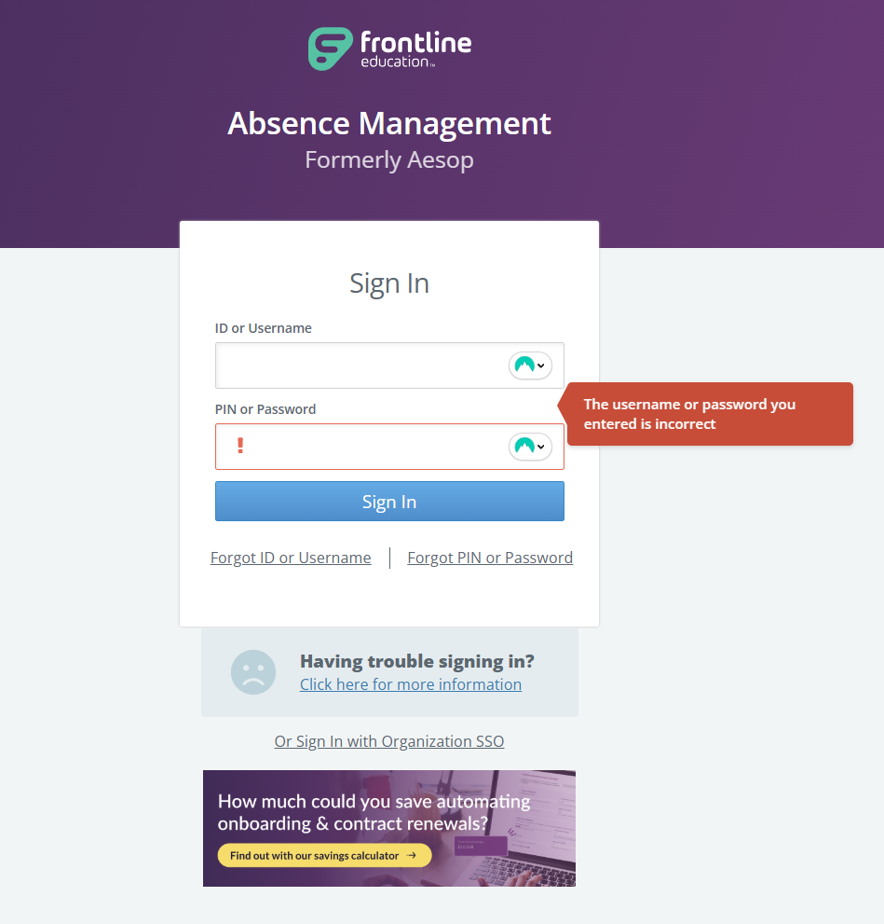

Exhibit B: Shows the deactivation of Mr. Golub’s Granite School District Account on May 10

n.b. Although the reason for the deactivation is given as “inactive,” Mr. Golub had been using the Granite School District system up until his access was deactivated on May 5, 2025.

